AI ASSISTED CODING
ASSIGNMENT - 12.1&12.5
NAME: P.SAI SHANKAR
HL-NO: 2303A52500 BATCH: 50
Lab 12.3 and 12.5:
Task-1:
import random
import time
import sys

# Increase recursion depth for deep quicksort
sys.setrecursionlimit(20000)
class Student:
def __init__(self, name, roll_number, cgpa):
self.name = name
self.roll_number = roll_number
self.cgpa = cgpa
def __repr__(self):
return f"{self.name} ({self.roll_number}): {self.cgpa}"
def generate_random_students(n):
students = []
for i in range(n):
name = f"Student_{i}"
roll_number = f"R{i:05d}"
cgpa = round(random.uniform(5.0, 10.0), 2)
students.append(Student(name, roll_number, cgpa))
return students
def quick_sort(arr):
if len(arr) <= 1:
return arr
pivot = arr[len(arr) // 2]
left = [x for x in arr if x.cgpa > pivot.cgpa]
middle = [x for x in arr if x.cgpa == pivot.cgpa]
right = [x for x in arr if x.cgpa < pivot.cgpa]
return quick_sort(left) + middle + quick_sort(right)
def merge_sort(arr):
if len(arr) <= 1:
return arr

mid = len(arr) // 2
left = merge_sort(arr[:mid])
right = merge_sort(arr[mid:])

return merge(left, right)
def merge(left, right):
result = []
i = j = 0

while i < len(left) and j < len(right):
if left[i].cgpa >= right[j].cgpa: # Descending
result.append(left[i])
i += 1
else:
result.append(right[j])
j += 1

result.extend(left[i:])
result.extend(right[j:])
return result
def display_top_students(students, n=10):
print(f"\nTop {n} Students:")
print("-" * 40)
for i, student in enumerate(students[:n], 1):
print(f"{i}. {student}")
print("-" * 40)
def main():
dataset_size = 5000 # Large dataset for comparison
print(f"Generating {dataset_size} student records...")
students = generate_random_students(dataset_size)

# Measure Quick Sort
students_copy_qs = list(students)
start_time = time.time()
sorted_qs = quick_sort(students_copy_qs)
qs_time = time.time() - start_time
print(f"Quick Sort Time: {qs_time:.6f} seconds")

# Measure Merge Sort
students_copy_ms = list(students)
start_time = time.time()
sorted_ms = merge_sort(students_copy_ms)
ms_time = time.time() - start_time
print(f"Merge Sort Time: {ms_time:.6f} seconds")

# Performance Comparison
print("\nPerformance Comparison:")
if qs_time < ms_time:
print(f"Quick Sort was faster by {ms_time - qs_time:.6f} seconds")
else:
print(f"Merge Sort was faster by {qs_time - ms_time:.6f} seconds")

# Display Top 10
display_top_students(sorted_qs)
if __name__ == "__main__":
main()

Output:
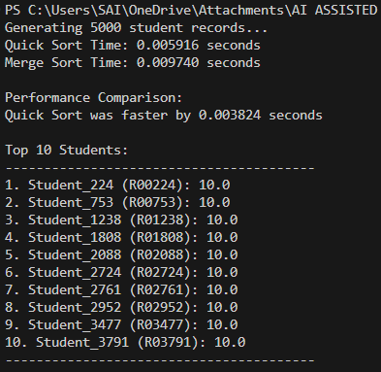

Task-2:
def bubble_sort(arr):
n = len(arr)
# Traverse through all array elements
for i in range(n):
# Last i elements are already in place, so we skip them
swapped = False
for j in range(0, n - i - 1):
# Traverse the array from 0 to n-i-1
# Swap if the element found is greater than the next element
if arr[j] > arr[j + 1]:
arr[j], arr[j + 1] = arr[j + 1], arr[j]
swapped = True

# If no two elements were swapped by inner loop, then break (termination)
if not swapped:
break
return arr

# Time Complexity Analysis:
# - Best Case: O(n) - When the array is already sorted.
# - Average Case: O(n^2) - On average, it takes n^2 comparisons.
# - Worst Case: O(n^2) - When the array is sorted in reverse order.
# - Space Complexity: O(1) - In-place sorting algorithm.
# Example usage:
if __name__ == "__main__":
sample_arr = [64, 34, 25, 12, 22, 11, 90]
sorted_arr = bubble_sort(sample_arr)
print("Sorted array:", sorted_arr)

Output:

Task-3:
import random
import time
import sys

# Increase recursion depth for deep recursive calls (e.g., Quick Sort on sorted/reverse-sorted lists)
sys.setrecursionlimit(2000)
def quick_sort(arr):
"""
Sorts an array using the Quick Sort algorithm.

Quick Sort is a divide-and-conquer algorithm. It picks an element as a 'pivot'
and partitions the given array around the picked pivot.

Average Time Complexity: O(n log n)
Worst Case Complexity: O(n^2) (occurs when the smallest/largest element is always picked as pivot)
Space Complexity: O(log n)
"""
if len(arr) <= 1:
return arr
else:
pivot = arr[len(arr) // 2]
left = [x for x in arr if x < pivot]
middle = [x for x in arr if x == pivot]
right = [x for x in arr if x > pivot]
return quick_sort(left) + middle + quick_sort(right)
def merge_sort(arr):
"""
Sorts an array using the Merge Sort algorithm.

Merge Sort is a divide-and-conquer algorithm that divides the input array
into two halves, calls itself for the two halves, and then merges the two sorted halves.

Time Complexity: O(n log n) (Best, Average, and Worst case)
Space Complexity: O(n)
"""
if len(arr) <= 1:
return arr

mid = len(arr) // 2
left_half = merge_sort(arr[:mid])
right_half = merge_sort(arr[mid:])

return merge(left_half, right_half)

def merge(left, right):
"""Helper function to merge two sorted lists."""
result = []
i = j = 0

while i < len(left) and j < len(right):
if left[i] < right[j]:
result.append(left[i])
i += 1
else:
result.append(right[j])
j += 1

result.extend(left[i:])
result.extend(right[j:])
return result
def compare_algorithms(size=1000):
"""
Compares Quick Sort and Merge Sort on random, sorted, and reverse-sorted lists.
"""
test_cases = {
"Random": [random.randint(1, 10000) for _ in range(size)],
"Sorted": list(range(size)),
"Reverse-Sorted": list(range(size, 0, -1))
}

print(f"--- Comparison of Quick Sort and Merge Sort (Input Size: {size}) ---")

for name, data in test_cases.items():
print(f"\nTest Case: {name}")

# Test Quick Sort
start_time = time.time()
quick_sort(data.copy())
qs_time = time.time() - start_time
print(f"Quick Sort: {qs_time:.6f} seconds")

# Test Merge Sort
start_time = time.time()
merge_sort(data.copy())
ms_time = time.time() - start_time
print(f"Merge Sort: {ms_time:.6f} seconds")
if __name__ == "__main__":
compare_algorithms()

print("\n--- Algorithm Complexity Analysis ---")
print("Algorithm | Best Case | Average Case | Worst Case")
print("----------|-----------|--------------|-----------")
print("Quick Sort| O(n log n)| O(n log n) | O(n^2)")
print("Merge Sort| O(n log n)| O(n log n) | O(n log n)")
print("\nNotes:")
print("- Merge Sort is stable and has consistent O(n log n) performance but uses O(n) extra space.")
print("- Quick Sort is usually faster in practice (better constant factors) but can degrade to O(n^2) if the pivot choice is poor.")

Output:
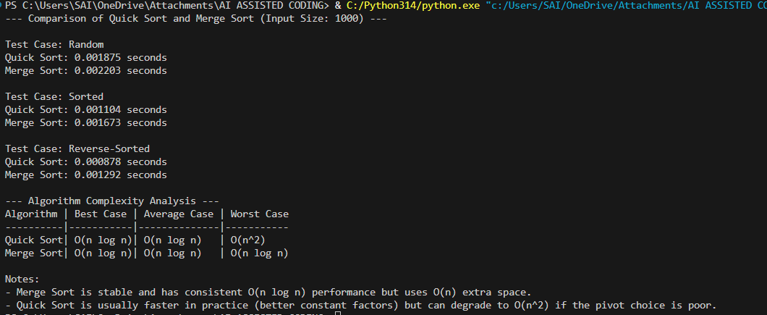

Task-4:
class Product:
def __init__(self, product_id, name, price, quantity):
self.product_id = product_id
self.name = name
self.price = price
self.quantity = quantity

def __repr__(self):
return f"Product(ID: {self.product_id}, Name: '{self.name}', Price: {self.price}, Qty: {self.quantity})"
class InventoryManager:
def __init__(self):
self.products = []
self.id_index = {}
self.name_index = {}
def add_product(self, product):
"""Adds product and updates hash map indexes for O(1) search."""
self.products.append(product)
self.id_index[product.product_id] = product
self.name_index[product.name.lower()] = product
def search_by_id(self, product_id):
"""O(1) Search by ID using Hash Map lookup."""
return self.id_index.get(product_id)
def search_by_name(self, name):
"""O(1) Search by Name using Hash Map lookup (exact match)."""
return self.name_index.get(name.lower())
def sort_by_price(self, reverse=False):
"""O(n log n) Sort using Timsort (Python's built-in sorted)."""
return sorted(self.products, key=lambda p: p.price, reverse=reverse)
def sort_by_quantity(self, reverse=False):
"""O(n log n) Sort using Timsort."""
return sorted(self.products, key=lambda p: p.quantity, reverse=reverse
# Example Implementation and Verification
if __name__ == "__main__":
inventory = InventoryManager()

# Adding sample data
products_data = [
(101, "Laptop", 1200.00, 15),
(102, "Smartphone", 800.00, 30),
(103, "Keyboard", 50.00, 100),
(104, "Monitor", 250.00, 25),
(105, "Mouse", 25.00, 200)
]

for p_id, name, price, qty in products_data:
inventory.add_product(Product(p_id, name, price, qty))
# Verification
print("--- SEARCH OPERATIONS ---")
print(f"Find ID 102: {inventory.search_by_id(102)}")
print(f"Find Name 'Monitor': {inventory.search_by_name('Monitor')}")

print("\n--- SORT OPERATIONS ---")
print("Products sorted by Price (Ascending):")
for p in inventory.sort_by_price():
print(p)
print("\nProducts sorted by Quantity (Descending):")
for p in inventory.sort_by_quantity(reverse=True):
print(p)

Output:
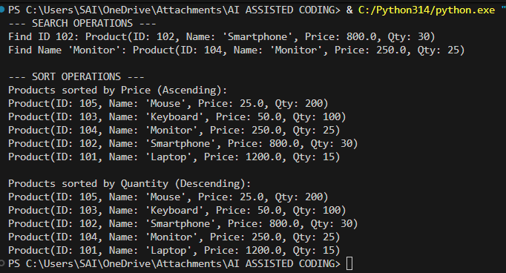

Task-5:
import heapq
import time

# Simulated stock data
stocks = [
{"symbol": "AAPL", "open": 150, "close": 158},
{"symbol": "TSLA", "open": 210, "close": 205},
{"symbol": "GOOGL", "open": 120, "close": 130},
{"symbol": "AMZN", "open": 98, "close": 95},
{"symbol": "MSFT", "open": 300, "close": 315}
]
# Calculate percentage change
for stock in stocks:
stock["change"] = ((stock["close"] - stock["open"]) / stock["open"]) * 100
# -----------------------------
# Heap Sort Implementation
# -----------------------------
def heap_sort(data):
heap = []
for item in data:
heapq.heappush(heap, (item["change"], item))
sorted_list = []
while heap:
sorted_list.append(heapq.heappop(heap)[1])
return sorted_list
# -----------------------------
# Hash Map for Searching
# -----------------------------
stock_map = {stock["symbol"]: stock for stock in stocks}
def search_stock(symbol):
return stock_map.get(symbol, "Stock not found")
# -----------------------------
# Performance Comparison
# -----------------------------
start = time.time()
heap_sorted = heap_sort(stocks)
heap_time = time.time() - start
start = time.time()
python_sorted = sorted(stocks, key=lambda x: x["change"])
python_time = time.time() - start
# -----------------------------
# Output Results
# -----------------------------
print("Stocks sorted by percentage change (Heap Sort):")
for s in heap_sorted:
print(s["symbol"], ":", round(s["change"], 2), "%")
print("\nSearch Result for TSLA:")
print(search_stock("TSLA"))
print("\nPerformance Comparison:")
print("Heap Sort Time:", heap_time)
print("Python sorted() Time:", python_time)

Output:
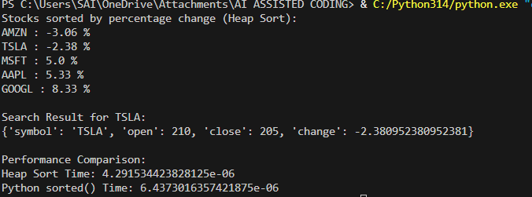

--------------------------------------------------------- 12.5 -----------------------------------------------------
Task-1:
def merge_sort(arr):
"""
Sorts a list using the Merge Sort algorithm.

Time Complexity:
Best Case: O(n log n)
Average Case: O(n log n)
Worst Case: O(n log n)
Space Complexity:
O(n) auxiliary space
"""
if len(arr) <= 1:
return arr
mid = len(arr) // 2
left = merge_sort(arr[:mid])
right = merge_sort(arr[mid:])
return merge(left, right)
def merge(left, right):
result = []
i = j = 0
while i < len(left) and j < len(right):
if left[i] < right[j]:
result.append(left[i])
i += 1
else:
result.append(right[j])
j += 1
result.extend(left[i:])
result.extend(right[j:])
return result
# Test
data = [38, 27, 43, 3, 9, 82, 10]
print("Sorted:", merge_sort(data))
Output:

Task-2:
def binary_search(arr, target):
"""
Performs binary search on a sorted list.

Returns index of target if found, otherwise -1.
Time Complexity:
Best Case: O(1)
Average Case: O(log n)
Worst Case: O(log n)
Space Complexity:
O(1)
"""
low = 0
high = len(arr) - 1
while low <= high:
mid = (low + high) // 2
if arr[mid] == target:
return mid
elif arr[mid] < target:
low = mid + 1
else:
high = mid - 1
return -1
# Test
numbers = [2, 5, 7, 9, 12, 15]
print("Index:", binary_search(numbers, 9))
Output:
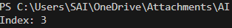

Task-3:
appointments = [
{"id":101,"patient":"Ram","doctor":"Dr.A","time":10,"fee":500},
{"id":102,"patient":"Sita","doctor":"Dr.B","time":12,"fee":300},
{"id":103,"patient":"Arjun","doctor":"Dr.C","time":9,"fee":700}
]

# Sort by time
sorted_by_time = sorted(appointments, key=lambda x: x["time"])
print("Sorted by Time:", sorted_by_time)
# Search by ID
def search_appointment(data, aid):
for a in data:
if a["id"] == aid:
return a
return "Not Found"
print(search_appointment(appointments,102))
Output:

Task-4:
tickets = [
{"ticket_id":1,"name":"Raj","train":1201,"seat":45,"date":20240610},
{"ticket_id":2,"name":"Anu","train":1103,"seat":12,"date":20240608},
{"ticket_id":3,"name":"Kiran","train":1502,"seat":30,"date":20240612}
]

# Sort by travel date
sorted_tickets = sorted(tickets, key=lambda x: x["date"])
print("Sorted by Date:", sorted_tickets)
# Search ticket
def search_ticket(data, tid):
for t in data:
if t["ticket_id"] == tid:
return t
return "Ticket not found"
print(search_ticket(tickets,2))
Output:

Task-5:
rooms = [
{"student_id":1,"room":205,"floor":2,"date":20240110},
{"student_id":2,"room":101,"floor":1,"date":20240105},
{"student_id":3,"room":305,"floor":3,"date":20240115}
]

# Sort by room number
sorted_rooms = sorted(rooms, key=lambda x: x["room"])
print("Sorted by Room:", sorted_rooms)
# Search student allocation
def search_student(data, sid):
for r in data:
if r["student_id"] == sid:
return r
return "Record not found"
print(search_student(rooms,3))
Output:

Task-6:
movies = [
{"id":1,"title":"Inception","genre":"Sci-Fi","rating":8.8,"year":2010},
{"id":2,"title":"Avatar","genre":"Sci-Fi","rating":7.9,"year":2009},
{"id":3,"title":"Joker","genre":"Drama","rating":8.5,"year":2019}
]

# Sort by rating
sorted_movies = sorted(movies, key=lambda x: x["rating"], reverse=True)
print("Sorted by Rating:", sorted_movies)
# Search movie
def search_movie(data, mid):
for m in data:
if m["id"] == mid:
return m
return "Movie not found"
print(search_movie(movies,1))
Output:

Task-7:
crops = [
{"id":1,"name":"Wheat","moisture":40,"temp":25,"yield":3.5},
{"id":2,"name":"Rice","moisture":60,"temp":28,"yield":4.2},
{"id":3,"name":"Corn","moisture":35,"temp":27,"yield":3.0}
]

# Sort by moisture level
sorted_crops = sorted(crops, key=lambda x: x["moisture"])
print("Sorted by Moisture:", sorted_crops)
# Search crop
def search_crop(data, cid):
for c in data:
if c["id"] == cid:
return c
return "Crop not found"
print(search_crop(crops,2))
Output:

